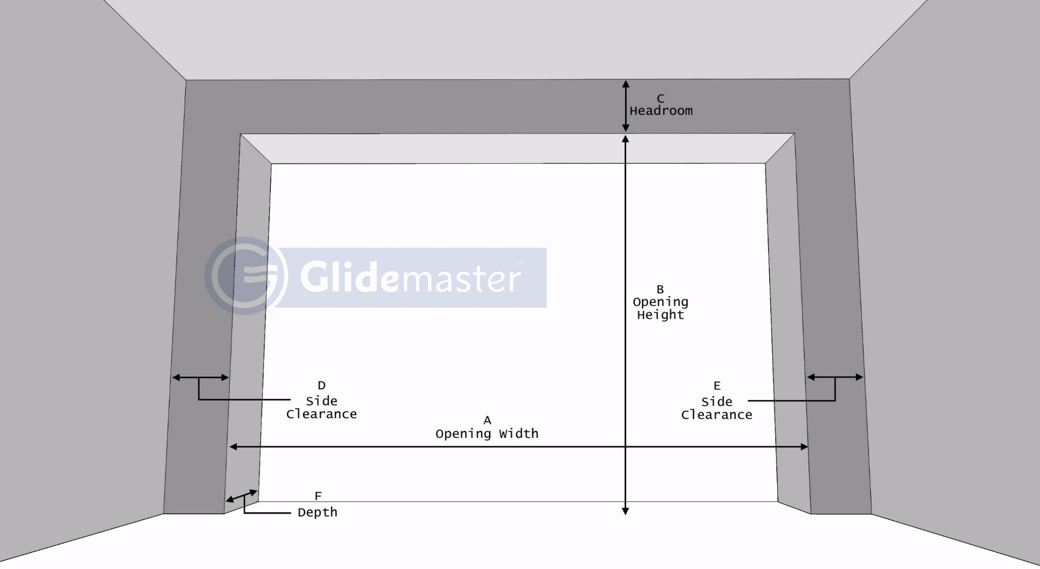
Clients Name :
Address :
:
Location :
Contact Number:
Mail ID :
Contact Person :
Date :
Notes :

 | A  (Clear Opening) Width | B  (Clear Opening) Height | C  Headroom | D  Side Clearance | E  Side Clearance | F  Depth
Opening 1
Opening 2
Opening 3
Opening 4
Opening 5
Opening 6
Opening 7
ALL DIMENSIONS ARE IN MM

